|  |  |
| --- | --- |
| TSBVILogoScalable | Texas School for the Blind and Visually Impaired  Outreach Programs  [www.tsbvi.edu](http://www.tsbvi.edu) | 512-454-8631 | 1100 W. 45th St. | Austin, TX 78756 |

Post-Secondary Transition for Students with Deafblindness:

Finding a Personal Life Path Starts with Interests

2021 Dakota AER Conference: Work It!

October 21, 2021

David Wiley, Texas Deafblind Project,

[wileyd@tsbvi.edu](mailto:davidwiley@tsbvi.edu)

# Finding a Personal Life Path Starts with Interests

When traditional paths to college and career may not seem like a good fit, successful transition planning starts with: identifying or discovering interests; examining the variety of contexts for pursuing interests; and understanding the variety of roles people take when engaging with others in home and community settings.

# Themes for Meaningful Transition Planning

* Meaningful transition planning starts with **discovering** individual student **interests**.
* Meaningful transition helps students **organize** interests into life activities in practical real-world **contexts**.
* Meaningful transition activities are **sustainable** with **support** after graduation?

# How Work Relates to Other Life Activities After Graduation.

* We all strive for a good quality of life.
* Transition planning often puts an emphasis on work, to the exclusion of other life activities.
* For each student, the team should consider what would be described as success for adult life.
* What daily life activities would result in purpose, satisfaction, and joy.

# A Framework for Exploring, Planning, and Organizing Adult Life Experiences

* Discover interests
* Consider contexts for pursuing interests
* Learn concepts and skills to adopt social and community roles needed in these contexts
* Students may need support in organizing potential life activities.

# Organization and Planning

In school students learn knowledge and skills. After graduation, students are expected to:

* Plan and organize life activities;
* Generalize what they have learned;
* Initiate life activities;
* Apply knowledge and skills in a variety of settings and contexts.

## Some students who are Deafblind may not be able to organize life activities due to barriers related to:

* Gathering incidental information;
* Concept development;
* Understanding of community roles.

## How do we know what we know?

* **Direct Learning**– Hands-on personal experience
* **Secondary Learning** – Others purposely sharing information using communication forms and methods we understand.
* **Incidental Learning** – Casually observing surroundings and other people. (How typical people get most information, but is unreliable for people who are DeafBlind.)

— <https://intervener.org/deafblindness/learning/>

# Discovering interests

* Interests are related to preferences, abilities, and connections.
* Revealed preferences may be more accurate than stated preferences.
* Try to identify what element of any activity is interesting or preferred.
* New routines in different settings create new information about interests and preferences.

# Contexts for pursuing interests

* We all engage in our interests in a variety of places for a variety of reasons: work; helping others; taking classes; social activities; leisure; home and self-care.
* All contexts are valuable if they bring us meaning, purpose, personal satisfaction, or joy.
* Learning more about a student’s community and home life gives insights about activities done in different settings, availability of support, and sustainability.

# Community and Social Roles

* Following interests and using skills after graduation in a variety of contexts often requires learning about and practicing new roles.
* As students gain experience, they can adopt new roles and responsibilities, and learn concepts in real-world environments.

## Opportunities to engage in community life come from understanding roles people ordinarily play.

* Being a good neighbor.
* Joining clubs and organizations.
* Offering to help someone or make a donation.
* Learning about occasions and giving gifts.
* Making an invitation.
* Planning and/or hosting a gathering.
* Taking more responsibility for something that is personally important.
* Considering the preferences of others.

# Organizing Contexts: how can an interest lead to community roles and life experiences?

* How could it be a job?
* How could it be a business?
* How could it help as a community service or in a place that needs volunteers?
* How could it bring you together with neighbors or others in the community?
* Could you do it for fun?
* Could it help you manage your home?
* Could it help you care for yourself?

# Resources

* Helen Keller National Center – [www.helenkeller.org/hknc](https://www.helenkeller.org/hknc)
* Perkins eLearning: Transition Resources – [www.perkinselearning.org/scout/topics/transition](https://www.perkinselearning.org/scout/topics/transition)
* National Center on Deaf-Blindness (NCDB) Transition Initiative – [www.nationaldb.org/national-initiatives/transition/](http://www.nationaldb.org/national-initiatives/transition/)
* National Center on Deaf-Blindness (NCDB) Info Center: Transition Planning –[www.nationaldb.org/info-center/educational-services/transition-planning/](http://www.nationaldb.org/info-center/educational-services/transition-planning/)

Texas School for the Blind & Visually Impaired

Outreach Programs

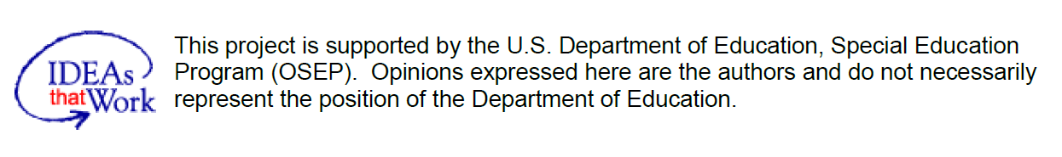

Figure 1 IDEAs that Work logo and OSEP disclaimer.